**UNIVERSITY OF INFORMATION TECHNOLOGY AND VIETNAM - KOREA COMMUNICATION**

**COMPUTER SCIENCE**



**Graduation Thesis**

**Create HaiNamCoin with blockchain, blockchain exchange**

Student implementation : Nguyễn Văn Nam 18IT340

: Phan Đức Hải 18IT319

Instructor : TS. Nguyen Duc Hien

***Da Nang, December 2022***

**UNIVERSITY OF INFORMATION TECHNOLOGY AND VIETNAM - KOREA COMMUNICATION**

**COMPUTER SCIENCE**



**Graduation Thesis**

**Create HaiNamCoin with blockchain, blockchain exchange**

Student implementation : Nguyễn Văn Nam 18IT340

: Phan Đức Hải 18IT319

Instructor : TS. Nguyen Duc Hien

SUPERVIOR’S COMMENT

…………………………………………………………………………………………………………………………………………………………………………………………………………………………………………………………………………………………………………………………………………………………………………………………………………………………………………………………………………………………………

ACKNOWLEDGEMENTS

While implementing and completing this project, I received the support and guidance of teachers and friends in the Department of Computer Science, University of Information and Communication Technology Viet Han - University of Danang. I want to express my sincere and deep gratitude to the teachers in the Faculty who taught and imparted the necessary knowledge and valuable experiences for me to be able to carry out this project.

First of all, I would like to thank my project supervisor, Dr. Nguyen Duc Hien, for his guidance, help, and discussion that gave me the knowledge and enthusiasm to design and develop this application.

Due to limited knowledge and experience, the implementation cannot avoid shortcomings. I look forward to teachers' comments in the information technology department of Vietnam-Korea University of Information and Communication Technology so that my project can be more complete.

Finally, I would like to thank the teachers in the Information Technology Department of Vietnam Korea University of Information and Communication Technology, especially Dr. Nguyen Duc Hien, for guiding and helping me complete this graduation project.

Thank you sincerely!

*Danang, December, 2022*

Born member (team leader)

STATEMENT OF AUTHORSHIP

As a result, I declare that this graduation project…is my research work. The sections that use references in the project are listed and clearly stated in the references section. At the same time, the data or results presented in the project are honest, not copied or plagiarized.

If wrong, I would like to take full responsibility and bear all the discipline of the subject and the school.

*Danang, December, 2022*

**NGUYỄN VĂN NAM**

TABLE OF CONTENTS

SUPERVIOR’S COMMENT 3

ACKNOWLEDGEMENTS 4

STATEMENT OF AUTHORSHIP 5

TABLE OF CONTENTS 6

LIST OF FIGURES 9

LIST OF TABLES 11

INTRODUCTION 12

1. Problem statement 12

2. Aims and Objectives 12

3. Structure of the thesis 12

CHAPTER 1. MUSCLE DEPARTMENT THEORY 13

1.1 Research rescue physical theory 13

1.1.1 Total mandarin about ReactJS 13

1.1.1.1 Gender introduce 13

1.1.1.2 The special show belong to ReactJS 14

1.1.1.3 Pros point and weakness point belong to ReactJS 17

1.1.2 Ethereum 18

1.1.2.1 Gender introduce 18

1.1.2.2 Way reading assignment Translate belong to Ethereum 18

1.1.2.3 One number concept thought need hold belong to Ethereum 19

1.1.3 Smart contract 19

1.1.3.1 Gender introduce 19

1.1.3.2 Profit useful belong to Smart contract 20

1.1.3.3 Need the what for create Candlestick one Smart contract 20

1.1.4 Total mandarin about Solidity 21

1.1.4.1 Gender introduce 21

1.1.4.2 Type evil Whether 21

1.1.5 KeystoneJS 22

1.1.5.1 Introduce 22

1.1.5.2 Feature 23

1.1.5.3 Requirements required 23

1.1.6 GraphQL 24

1.1.6.1 Introduce 24

1.1.6.2 Features of GraphQL 24

1.1.7 Part conclude thesis 25

1.1.8 NestJS 26

1.1.8.1 Structure 26

1.1.8.2 NestJS Features 27

1.1.9 Python 27

1.1.10 NodeJs 28

1.1.11 Html 29

1.1.12 CSS 29

1.1.13 Bootstrap 30

1.1.14 ExpressJs 30

1.1.15 Tflearn 31

CHAPTER 2. ANALYSIS AND DESIGN NEXT SYSTEM THINKING 32

2.1 Sàn giao dịch blockchain 32

2.1.1 Main positions 32

2.1.1.1 View Cryptocurrency Market Information 32

2.1.1.2 Create an e-wallet that stores Ethereum 32

2.1.1.3 Create, add total supply for your private token 33

2.1.1.4 Fast loan with parameter customization 33

2.1.1.5 Save quick loan history and statistics 33

2.1.1.6 Manage login to retrieve transaction history information 34

2.1.1.7 Invite friends to experience the app 34

2.1.2 Use case diagram 34

2.1.2.1 Overall diagram 34

2.1.2.2 View Cryptocurrency Market Information 36

2.1.2.3 Create an e-wallet that stores Ethereum 37

2.1.2.4 Create, add total supply for your private token 38

2.1.2.5 Borrow fast with parameter customization and save transaction history 39

2.1.3 Sequence Diagram 39

2.1.3.1 View Cryptocurrency Market Information 40

2.1.3.2 Create an e-wallet that stores Ethereum 41

2.1.3.3 Create, add total supply for your private token 41

2.1.3.4 Quick loan with custom parameters and save transaction history 42

2.1.4 Class diagram 43

2.1.5 Database 43

2.2 Virtual assistant (Trợ lý ảo) 47

2.2.1 Identify the actors (Actors): 47

2.2.2 Define use cases: 47

2.2.2.1 User 47

2.2.3 Specification of use cases: 48

2.2.3.1 Time display use case 48

2.2.3.2 Check the weather 48

2.2.3.3 Listen to music on youtube 50

2.2.3.4 Search function 52

2.2.3.5 See definition from Wikipedia 53

2.2.3.6 Read the paper 54

2.2.3.7 Open the app 55

2.2.3.8 Text-to-voice divination 56

2.2.3.9 Voice to Text 57

CHAPTER 3. PROMOTION DECLARATION AND DISCLOSURE RUN TO TRY ON EXPERIENCE 59

3.1 Lip school develop declare 59

3.2 System Deployment 59

3.2.1 Implementation stages 59

3.2.2 Algorithm analysis 65

3.3 Demo results and program instructions 68

3.3.1 View Cryptocurrency Market Information 68

3.3.2 Create an e-wallet that stores Ethereum 68

3.3.3 Create, add total supply for your private token 70

3.3.4 Fast loan with parameter customization 70

3.3.5 Save quick loan history and statistics 77

3.3.6 Manage login to retrieve transaction history information 81

3.3.7 Invite friends to experience the app 82

3.3.8 Evaluate 83

CONCLUSIONS AND SUGGESTIONS 84

1. Conclusions 84

2. Suggestions 84

REFERENCES 85

LIST OF FIGURES

Figure 1‑1 Jordan Walke, People shining create go out ReactJS. 13

Figure 1‑2 14

Figure 1‑3 15

Figure 1‑4 16

Figure 1‑5 18

Figure 1‑6 21

Figure 1‑7 22

Figure 1‑8 24

Figure 1‑9 25

Figure 1‑10 26

Figure 2‑1 35

Figure 2‑2 36

Figure 2‑3 37

Figure 2‑4 38

Figure 2‑5 39

Figure 2‑6 40

Figure 2‑7 41

Figure 2‑8 41

Figure 2‑9 42

Figure 2‑10 42

Figure 2‑11 43

Figure 2‑12 47

Figure 2‑13 48

Figure 2‑14 50

Figure 2‑15 51

Figure 2‑16 53

Figure 2‑17 54

Figure 2‑18 55

Figure 2‑19 56

Figure 2‑20 57

Figure 2‑21 58

Figure 3‑1 61

Figure 3‑2 62

Figure 3‑3 64

Figure 3‑4 64

Figure 3‑5 65

Figure 3‑6 65

Figure 3‑7 66

Figure 3‑8 67

Figure 3‑9 68

Figure 3‑10 69

Figure 3‑11 70

Figure 3‑12 71

Figure 3‑13 72

Figure 3‑14 73

Figure 3‑15 73

Figure 3‑16 74

Figure 3‑17 75

Figure 3‑18 75

Figure 3‑19 76

Figure 3‑20 76

Figure 3‑21 77

Figure 3‑22 77

Figure 3‑23 78

Figure 3‑24 79

Figure 3‑25 80

Figure 3‑26 81

Figure 3‑27 82

Figure 3‑28 82

LIST OF TABLES

Table 2‑1 44

Table 2‑2 45

Table 2‑3 46

Table 2‑4 46

Table 2‑5 48

Table 2‑6 49

Table 2‑7 49

Table 2‑8 50

Table 2‑9 51

Table 2‑10 52

Table 2‑11 53

Table 2‑12 54

Table 2‑13 55

Table 2‑14 57

Table 2‑15 58

Table 3‑1 *The speed of the Kovan network is quite fast compared to other networks of Ethereum* 59

Table 3‑2 62

Table 3‑3 63

[INTRODUCTION](https://docs.google.com/document/d/1DvJeMkOFMp9-ic5PLTCuWU5VyChuq-4p/edit#heading=h.lnxbz9)

1. Problem statement

Traditionally, to get a loan from a bank, it requires the borrower to have collateral or information that can prove income to be able to repay the loan on time. So what if the poor people , disadvantaged people do not have collateral and do not meet income conditions, they will not be able to borrow any money (not to mention policy cases). The flashloan application can solve this problem on the blockchain network system.

1. Aims and Objectives

In order to solve the lending needs without going through complicated procedures or constraints, bringing flexibility, safety and transparency in loan services, this topic has solved 3 main issues such as: after :

-         Helping people in need of loans to invest or generate profits in some other form on the cryptocurrency market.

-         Help give user using cryptocurrency is collateralizing any asset A replacing any other collateral B

-         Make the repayment of other mortgage loans easy and flexible

In this project, focus only on the ability to make a profit in the form of arbitrage, using the way of trading on decentralized exchanges.

1. Structure of the thesis

After the Introduction, the thesis is structured in three chapters:

*Chapter 1, Muscle department physical theory.*

*Chapter 2, System analysis and design.*

*Chapter 3, Implementation and results evaluation Conclude thesis and direction play develop.*

Finally, there are Conclusions, Suggestions, References and Appendices related to the topic.

# MUSCLE DEPARTMENT THEORY

## Research rescue physical theory

### Total mandarin about ReactJS

#### Gender introduce

React (or ReactJS, React.js) to be one letters institute Javascript code the source open for build build reusable interface components. It was created by *Jordan Walke* , an engineer Software Engineer at Facebook. People affected by XHP (A component platform HTML for PHP). React first rolled out to 's Newsfeed app Facebook five 2011, after there Okay develop declare give Instagram.com five 2012. It Okay open code the source (open-sourced) in JSConf US May five 2013 [7].



Figure 1‑1 Jordan Walke, People shining create go out ReactJS.

Special count belong to ReactJS:

- Private thought belong to ReactJS to be build build go up the components yes count re history use, easy for problem breakdown, testing. It makes it easy to manage, open system wide, this if it is Angular JS, it requires structure and writing code right real dark superior.

- ReactJS always hold the components live status Thai stateless (lots of best yes body) cause ta easy easy manager reason _ by it barely is different what one Page static HTML. Copy The body of these components has no state, it takes input from beside outside and only show market go out rely enter the head enter there, thing this solution prefer in star it Carry count re history use and easy easy give testing.

#### The special show belong to ReactJS

Components:

- A short piece of code that is meant to represent a function or object best determined, yes can re history use.

- A React application can use dozens, or hundreds of components contact conclude and soy sauce works with together.

- I yes can create go out one components is equal to way extends are from Components like after:

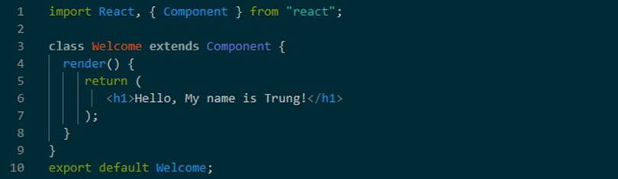

Figure 1‑2

- The most important method is render(), which is triggered when the components already available ready for Okay render go up above Page. In jaw this, will return a description of what you want React to render on the page. Jaw render main to be tissue description tool can belong to deliver face People use in any keep time point any. So if the data changes, React will take care of updating again deliver face with data corresponding.

Props:

- Pine believe Okay transmission are from components this luxurious components is different Okay call to be props.

- Props belong to one components yes can to be one objects, functions, string, number

…. It contain pine believe about Fort part there.

State:

- A component in React has two ways to get props and state information. Is not like props, state belong to first components No Okay transmission are from beside outside enter. A component determines its own state. To create state give components, ta will right declare 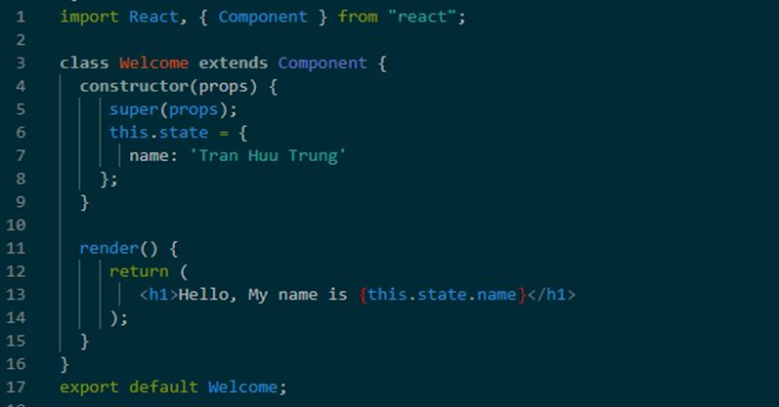newspaper it in jaw constructor.

Figure 1‑3

- This.state here is an object. To access the states we use the France: this.state.name_of_property. And way spectrum variable for replace change state belong to one components to be use jaw setState(). Lyfecycle:

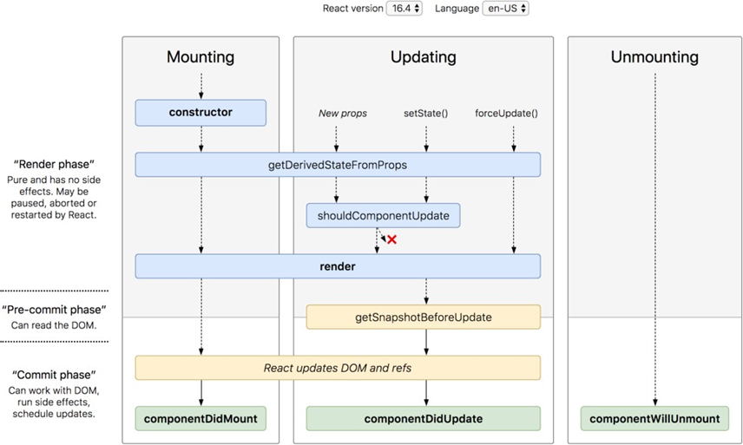

Figure 1‑4

- An equally characteristic component of React's Props and State is LifeCycle. LifeCycle to be the direction awake Okay write available access access arrive ever time point in one ring life belong to components, are from there yes can develop declare  idea thought one way easy easy but sacred motion.

- **constructor(props):** This function is the constructor, which runs immediately after component is created, the input of this function is props (i.e. properties belong to components Okay use for transmission evil Whether are from beside outside enter). In jaw this also yes can start create state give components.

- **Render:** A required function, as this is the output of the component. It is responsible duty pay about one opposite to statue JSX these what want? show market go out beside outside.

- **componentDidMount:** A function that is called right after the interface is built render finished, yes means to be when the deliver face presently go up will call jaw this. In jaw this yes can use for take data are from api, server… and setState data Whether go out.

- **componentWillUnmount:** Function this Okay call when the components type cancel DOM, perform cleanup operations, remove redundant elements, and cancel the timer…

- **componentDidUpdate(prevProps, prevState):** This function is called immediately after when the components re-rendered.

#### Pros point and weakness point belong to ReactJS

Pros point:

- ReactJs is extremely efficient: Reactjs creates its own virtual DOM – where the components real events exist in above there. Thing this will help cabbage good brand rate so many. Reactjs also calculates which changes need to update len DOM and just execute them. This helps Reactjs avoid unnecessary operations above DOM but lots of spend fee.

- ReactJs makes it easier to write JS code: It uses syntax special bye to be JSX (Javascript open wide) give permission ta mix Between code HTML and Javascript. You can add HTML snippets to the render function No need right connect Chain. Here to be special count animal taste belong to Reactjs. It will transfer convert HTML fragments into HTML object constructors with variable change JSX.

- Reactjs has many development tools: When starting Reactjs, don't forget to install set the Chrome extension for Reactjs. It helps fix errors program easier. After installing this application, the user will have a direct view of the virtual DOM as if you were looking at the pine DOM tree often.

- Server layer rendering: One of the problems with single-page applications is SEO optimization and page load time. If all the construction and display the page is executed on the client, the user will have to wait for the page to work, initialize and show up. This is actually slow. Or if suppose person What about disabling Javascript? Reactjs is a component library, it can both render outside the browser using the DOM and also render is equal to the Chain HTML but server pay about.

- do job with question topic kiểm TRA deliver area: It pole period easy for write the kiểm TRA case deliver face Because virtual DOM is installed complete full is equal to JS.

- High performance for applications with constantly changing data, easy give tell maintain and fixes.

Cons point:

- Reactjs only serves the View layer. React is just a View Library, isn't it? must be an MVC framework like other frameworks. This is just a letter Facebook's library helps to render the view. So React won't have Model and Controller parts, which must be combined with other libraries. React also will No yes 2-way binding nice to be Ajax.

- Tich fit Reactjs enter the framework MVC transmission system love bridge need right structure Figure again.

- React rather heavy if so with the framework is different, React yes size ruler soy sauce soy sauce with Angular (About 35kb so with 39kb belong to Angular). In when the there Angular to be one framework complete correction.

### Ethereum

#### Gender introduce



Figure 1‑5

Ethereum (ETH) is a platform that runs on Blockchain technology. Okay play develop by Vitalik Buterin enter last five two thousand and thirteen and it Okay to add enter position power smart contract.

ETH or also known as Ether is the currency in the Blockchain system of Ethereum. This is what we can trade on exchanges deliver Translate presently in.

#### Way reading assignment Translate belong to Ethereum

**TxHash –** Also known as Transaction ID, TxHash is a way to search for a deliver Translate tool can blockchain Ethereum.

· **Block height –** Is number order of block that transaction is added. It mean Miners will process your transaction when they mine Ethereum. In other words, the number represents deliver Translate there Okay take place live block number some in Chain blockchain.

· **TimeStamp –** Time point handling deliver Translate.

· **Value -** Number quantity money ETH in trip deal there.

· **Gas limit –** Number Gas maximum but Friend available ready pay when the real presently deliver Translate.

· **Gas Used by Txn –** Number Gas real use.

· **Gas price –** Price belong to Gas, price this Okay decide determined by worker dig.

· **Actual Tx Cost/Fee –** Fee Friend right pay, fee this Okay count is equal to Gas Price * Gas Used.

· **Nonce –** The number of times that address has transacted. For example, you transfer money 100 times then child number there will to be 100.

#### One number concept thought need hold belong to Ethereum

**a. Wallet Ethereum**

Like Bitcoin, Ethereum wallet is a type of wallet used to store Ethereum in order to dress service about deliver Translate, buying sell, handed out change and store store copper money this.

**b. Land only Ethereum**

An Ethereum address is a similar concept to a Bitcoin address, which is a sequence of numbers so that others can transfer ETH in your wallet. When need to move ETH goes, you need know land only wallet Ethereum belong to People there.

**c. Tokens Ethereum – ERC-20**

Ethereum tokens are issued on a cryptocurrency platform to serve a item destination tool body.

ERC-20 defines a common list of rules for tokens Ethereum to follow the larger Ethereum ecosystem, allowing developers to correctly predict the interaction between strings. These rules cover how the codes Messages are transferred between addresses and data access in each message newspaper.

### Smart contract

#### Gender introduce

Smart contract (smart contract) is a contract management protocol. That is a special set of protocols whose goal is to contribute, validate, or contract negotiation and performance. Smart contract allows us to deploy Transactions do not need to go through an intermediary third party. These transactions are complete completely traceable and cannot be tampered with or reversed. Smart contract contains in itself all the details about the terms and execute them one by one way automatic.

#### Profit useful belong to Smart contract

Smart Contract is an application that takes advantage of all the strengths of the company Blockchain technology brings so it has many benefits, below are the main benefits belong to it.

a. **Automation** : The process by which the contract is executed is automatically equal. Copper When you are the creator of the contract, you no longer have to depend on brokers and lawyers nice any period Who is different. So, it also erase cancel the risk muscle arrive are from beside rank father.

b. **Don't get lost** : Your documents are encrypted on a ledger general, which means that it cannot be lost. With Blockchain, all friends are yes save store talent Whether belong to Friend.

c. **Safety** : Blockchain will ensure the safety of your documents. Not one hacker any yes can anvil threaten arrive they.

d. **Speed** : Smart contracts using programming languages, partial code software for automation terms, saving hours for those labour job No need set.

e. **Savings** : Smart contracts save you tons of money by deleting cancel sew central time.

f. **Accurate** : Automated contracts are not only faster and cheaper, but also avoid Okay the error often see when the write paper sheet.

#### Need the what for create Candlestick one Smart contract

a. **Contract subject:** Smart Contract right access is granted come to product product/translation service paralysis list in fit copper to maybe on one's own dynamic lock up open lock up they.

b. **Letter sign electricity death:** Socks chief the beside greed family enter Smart Contract even right copper idea develop declare satisfied favorable is equal to the lock up fish core (signature electricity death) belong to surname.

c. **Contract terms:** The terms in a Smart Contract are in the form of a Chain the work. C _ parties involved family fit copper even right sign accept .

d. **Decentralized platform:** Smart Contract after completion will be uploaded Blockchain of similar decentralized platform applied and distributed to nodes belong to communication that.

### Total mandarin about Solidity

#### Gender introduce



Figure 1‑6

Solidity is an object-oriented, high-level language for implementing contracts clever. Smart contracts are programs that govern the behavior of documents clause in status Thai Ethereum.

Solidity is influenced by C++, Python and JavaScript and is designed to aim item pepper Machine virtual Ethereum (EVM).

With Solidity, you can create contracts for uses such as voting, cause fund add copper, fight price blind and wallet multi signature.

#### Type evil Whether

a. ***Array***

The struct variable allows us to define determined multiple data structures than. Solidity also there are arrays. You can create arbitrary fixed or flexible arrays. Arrays with struct is flexible because the length is not specified. So we can add the statue enter enter number but No yes gender term.

b. ***Pragma version***

Socks chief the code the source even start head with one session copy “version pragma“-one declare dad belong to session copy belong to submit record Translate Solidity. Here to be for compartment block the question topic with future compiler versions ability introduce changes have can break broken code belong to People use.

c. ***Address***

Ethereum blockchains are made up of accounts, e.g. bank accounts row. An account have a balance of Ether (the currency used on Ethereum blockchain), you can send and receive Ether payments to other accounts, just like your bank account can transfer money to the accounts other bank. And each account will have an address. An FCM implementation includes two main components for sending and receiving:

For example, the Ethereum blockchain is made up of addresses. Each account has one address private. It has the following form:

0x0cE440255306E921F41612C46F1v6df9Cc969183.

Every land only yes one quantity Ether best determined, to be number money virtual Okay use above blockchain, and yes can give and take Ether from the land just different.

d. ***Mappings***

Mappings are another way to store organized data in Solidity. Mappings are a warehouse save store price treat main for save store and Find evil sword Whether.

e. ***Memory and Storage***

In Solidity, there are two places to store variables: in storage or in memory. One variable stored in memory is only temporary, it remains when the functions are used, then will be deleted. A variable stored on storage stays there forever. You also don't need to worry about variable Okay save where, Because Solidity will handling it help Friend.

However, in some cases, you want to detail where a variable is stored best determined. Solidity will show market give Friend by word lock memory and storage.

### KeystoneJS



Figure 1‑7

#### Introduce

KeystoneJS is an open source framework for developing database-driven websites, applications and APIs using Nodejs.

Keystone will configure Express - the actual Nodejs web server for you and connect to your MongoDB database using Mongoose (Mongoose is an object data modeling (ODM) library that provides a rigorous modeling environment for your data, implementing the structure as needed while maintaining the flexibility that makes MongoDB so powerful)

#### Feature

**- Dynamic Routes** : Keystone starts with the best components to set up your MV* application and makes it easy to manage Templates, Views, and Routes.

**- Database Fields:** IDs, Strings, Booleans, Dates, and Numbers are the building blocks of your database. Keystone builds on these with useful, practical field types like name, email, password, address, image, and relational fields (and more)

**- Admin UI is auto-generated:** Whether while you're building your app or when it's being run as a database content management system, Keystone's UI saves you time and helps manage your data. your material easily.

**- Simpler Code:** Sometimes, it can be complicated to code to do simple things. Keystone keeps things simple – like loading data before displaying it in View.

**- Form handling:** Want to validate a Form, upload an image and update your database with a single line? Keystone can do that, based on the data models you've defined.

**- Session Management:** Keystone provides built-in session management and authentication features, including auto-encryption for password fields.

#### Requirements required

Make sure you have the Node.js JavaScript runtime installed. Keystone 4 has been most tested with Node 6, but should be compatible with newer production releases. We recommend using Node LTS (Long Term Support) releases for their extended support lifecycle and stability.

You will also need access to a locally installed or remotely hosted MongoDB database server. Keystone 4 should be compatible with current production releases of MongoDB.

You will need knowledge of working with JavaScript, Node.js, and npm to use Keystone. Basic familiarity with database and MongoDB concepts will also be helpful.

Currently the project is using Keystone v5 and v6 is in the process of development, not optimized and stable to use.

### GraphQL

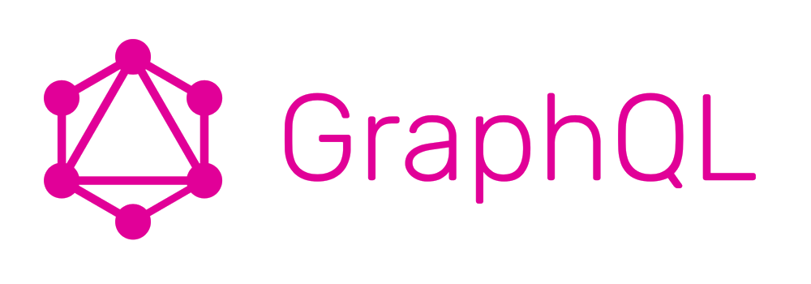

Figure 1‑8

#### Introduce

GraphQL is an open source data manipulation and querying language for APIs that gives clients an easy way to request exactly what they need, making API development easier over time. GraphQL was developed internally by Facebook in 2012 before going public in 2015.

GraphQL includes 3 features including:

· Allows clients to determine exactly what data they need

· GraphQL makes it easier to aggregate data from multiple sources

· Use a type system to declare data.

#### Features of GraphQL

**a. Efficient, Powerful & Convenient**

• To make it easier for you to visualize the strengths of GraphQL, we need to talk about REST (Representational State Transfer) — the kind of popular API protocol that GraphQL wants to replace.

• Before GraphQL, programmers used to use REST to query data. However, the problem with REST is that its data will often return too much, redundant than the requested information; sometimes too little. Either way, the performance of the application will be greatly affected.

• With GraphQL, whatever information you request from the API will only produce what you need, nothing more, nothing less.

**b. Schema Defining and Type System Features**

* GraphQL has its own system that is used to define the schema of an api. All types listed in an API are written in schema then history use GraphQL Schema Definition Language(SDL) (SDL is the most concise way to declare information in a GraphQL schema. In fact, SDL is part of the official GraphQL specification).
* You can think of this schema as a rule between the client and the server that defines how the client accesses data from the client.

**c. Fetching Data**

The way GraphQL loads data is different from REST

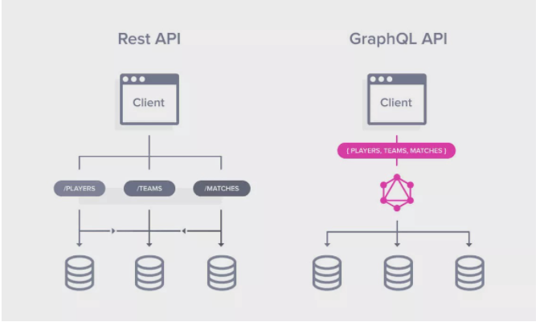

Figure 1‑9

In REST, each information source is an endpoint, for each endpoint you have to make a different data call, and the data each endpoint returns may be more or less than the data you requested. Meanwhile, with GraphQL, you only need to make a call to 1 endpoint and the system will do the rest, returning information from 3 sources for you.

### Part conclude thesis

By researching and learning about the above technologies, I have successfully applied them labour the concept thought and muscle processing Hentai dynamic belong to they in thing sentence time this for create go out quite a complete and professional application.

Some technologies may not be new, but they are widely used and are coin direction give branch labour turmeric play develop part soft. Do there, understand concept thought to be very important, it helps me to apply it correctly technology for each project, to enhance brand fruit and ability power use

### NestJS

#### Structure



Figure 1‑10

NestJS is built from many different elements, but the most important are the following three main components:

* Modules

Modules: used to organize code and divide features into reasonably reusable units. TypeScript files are grouped using Decorator “@Module.” The “@Module” Decorator provides metadata to NestJS that helps it identify components, controllers, or other resources to structure an efficient, scientific application.

* Providers

An indispensable component in NestJS is Providers. It is similar to a service that helps handle complex, logical tasks that Controller handlers cannot do. Providers can be created and injected into other Controllers or Providers.

* Controllers

The controllers's main function is handling incoming requests and responses to the client side. After receiving the HTTP request, it will compose the correct, most appropriate answer to send. Each Controller will have its routes to help it perform different tasks well.

#### NestJS Features

NestJS framework is extremely popular with users because it possesses valuable features such as:

Promote TypeScript development.

Use TypeScript and allow this programming language to adapt quickly to respond to any changes in JavaScript.

Simple install, easy to use, and takes little time to learn and research.

Boost performance and ease development with the powerful CLI command-line interface.

Resources are diverse, rich, detailed, and well-maintained.

Extensibility, development, and maintenance of the codebase in action.

As the open source of Node.js, the most powerful development in the past few years.

Modular support helps applications integrate popular technologies and concepts such as Caching, WebSockets, Logging, Validation, TypeORM, Mongoose, etc.

Made for Micro-services and Monoliths.

### Python

Python is a high-level object-oriented programming language used to develop websites and various applications. Python was created by Guido van Rossum and is developed in an open source project.

With an extremely simple and elegant syntax, Python is the perfect choice for those who are learning to code for the first time. However, this is also a language that is famous for its rigor, speed, and power, and is available in all operating systems.

In fact, Python is used in many different professions, such as:

· Machine Learning and AI

· Data Science and Data Visualization: Python is considered as one of the most popular programming languages in the field of Data Science worldwide.

· Game development

· Software Development

· Website development

### NodeJs

Node.js is a platform that runs on the V8 JavaScript runtime - a blazing fast JavaScript interpreter that runs on the Chrome browser. Normally you could just download the V8 and embed it in anything; Node.js does it for web servers. JavaScript is just a language after all - so there's no reason to say it can't be used on a server environment as well as in a user's browser.

In a typical LAMP (Linux-Apache-MySQL-PHP) server environment, you have an underlying Apache or NGINX web server, with PHP running on top of it. Each connection to the server spawns a new thread, and this causes the application to quickly become slow or overloaded - the only way to support more users is by adding more servers. It simply doesn't have good scalability. But with Node.js this is not a problem. There isn't an Apache server that listens for incoming connections and returns HTTP status codes - you'll have to manage that server's core architecture yourself. Fortunately, there are a number of modules that make this easier, but it can still be a bit daunting when you're just starting out. However, the result is a web application with high execution speed.

Klout – A social statistics web application built on top of Node.js because of its high execution speed.

Klout – A web application for social activity statistics

built on top of Node.js because of the advantages of high execution speed

JavaScript is an event-based language, so anything that happens on the server generates a non-blocking event. Each new connection spawns an event; data received from an upload form generates a data-received event; querying data from the database also generates an event. In practice, this means that a Node.js site will never be locked up and can support tens of thousands of concurrent users. Node.js plays the role of the server - Apache - and interprets the application code that runs on it. Like Apache, there are many modules (libraries) that can be installed to add additional features and functionality - like data storage, Zip file support, Facebook login, or payment gateways. Of course, it doesn't have as many libraries as PHP, but Node.js is still in its infancy and has a very strong community behind it.

A core concept of Node.js is asynchronous functions - so basically everything runs on this platform. With most server scripting languages, the program must wait for each function to finish executing before it can continue to run. With Node.js, you define functions that will run to complete a certain task, while the rest of the application is still running concurrently. It's a complex topic that I won't go into too much of in this article, but it's one of the hallmarks of Node.js, so it's important to master it.

### Html

HTML stands for HyperText Markup Language((See more at http://en.wikipedia.org/wiki/HTML)) (translated as HyperText Markup Language) used to create a web page , on a website may contain many pages and each page is referred to as an HTML document (sometimes I will write as an HTML file). The father of HTML is Tim Berners-Lee, also the founder of the World Wide Web and president of the World Wide Web Consortium (W3C - the organization that sets standards on the Internet environment).

An HTML document is formed by HTML elements (HTML Elements) specified by pairs of tags (tags), these pairs of tags are enclosed by a parenthesis. An HTML file will include HTML elements and be saved with the extension .html or .htm.

### CSS

CSS is a language for styling web pages – Cascading Style Sheet language. It is used to style and style elements written in a markup language, such as HTML. It can control the format of many web pages at the same time to save effort for web writers. It distinguishes the display of web pages from the main content of the page by controlling layout, colors, and fonts. CSS was developed by the W3C (World Wide Web Consortium) in 1996, for a simple reason. simple. HTML is not designed for tagging to help with web page formatting. You can only use it to “bookmark” the site. Tags like <font> were introduced in HTML version 3.2, it caused a lot of trouble for programmers. Because the website has many different fonts, different background colors and styles. To rewrite the code for the website is a long, arduous process. So the CSS generated by W3C is to solve this problem. The correlation between HTML and CSS is very close. HTML is the markup language (the foundation of the site) and CSS defines the style (all that makes up the website interface), they are inseparable. CSS is not possible in theory, but then the website will be more than just a page containing text and nothing else.

### Bootstrap

Simply put, Bootstrap is pre-written code to help developers easily create website interfaces that are compatible with mobile screens. Bootstrap is a framework that includes HTML templates, CSS templates and JavaScript templates for developing responsive websites. Bootstrap is essentially a set of syntaxes that perform specific functions. To work properly, Bootstrap needs to have the main files that manage the user interface and functionality of the website. Those are 3 files:

Bootstrap.css: a CSS framework that organizes and manages the layout of the website. To perform a specific action, two structures need to exist at the same time: HTML manages the content and structure of the website, and CSS handles the website layout.

Bootstrap.js: This file is the core of Bootstrap. Bootstrap.js includes the JavaScript files responsible for the interaction of the website.

Glyphicons: Associate icons with certain actions and data in the user interface.

### ExpressJs

Javascript is a website programming language, which is integrated and embedded in HTML and makes the website come alive. This is a scripting language, built on the built-in development object or simply self-defined. Javascript gives you more control over the behavior of your website than just HTML. There are a few very familiar practical applications of Javascript such as slideshows, pop-up ads or Google's autocomplete feature, etc. They are all written in Javascript language. Javascript was first known in September 1995, created in just 10 days by Brendan Eich – a Netscape employee. In fact, the first name people used for this programming language was Mocha, then changed to Mona and continued to transform into Livescript before becoming the popular Javascript programming language as it is now. The first version of this programming language was exclusively restricted by Netspace and had only limited features. However, it continues to develop over time and perfect to the present time thanks to the continuous work of the community of programmers. Until now, Javascript has developed and works in almost every browser and from mobile to desktop. In just over 20 years, Javascript has gone from being a programming language to being the most important tool in a web developer's toolkit.

### Tflearn

TFlearn is a modular and transparent deep learning library built on top of Tensorflow. It is designed to provide a higher level API for TensorFlow to facilitate and speed up tests, while remaining completely transparent and interoperable with it. However, even with TensorFlow, we are still faced with the choice of using the previous front-end framework. Should we directly use TensorFlow, or TF Learn, or Keras, or the new TF-Slim library that Google released in TensorFlow.

Keras is a high-level neural network API, written in Python and capable of running on top of TensorFlow, CNTK, or Theano. It was developed with a focus on enabling agile testing. Being able to go from idea to result with as little lag as possible is key to doing good research.

# ANALYSIS AND DESIGN NEXT SYSTEM THINKING

This chapter will go into detail about the requirements, describe the non-functional requirements, design constraints, and other essentials to provide a complete description and complete good _ about the love bridge give application use. It will bag including Sister thingallows the pe shift history use, sequence diagram, diagram thing class, and database. From there, an overview of the functions will be displayed capabilities that the application can fulfill. In addition, it also defines the architecture, modules, and data. Whether give one system to answer application, the love bridge already states go out.

The system design process is to provide enough data and detailed information about the system and is an element of the system that rformance of behaviors consistent with architecture as well as defined in the models, modules, and views of the system architecture. It shows the components of the application, the structure of tables evil Whether, termites mandarin system belongs to the weak element create Candlestick system.

## Sàn giao dịch blockchain

### Main positions

#### View Cryptocurrency Market Information

In this feature, users can easily find information on fluctuations and price differences of coins circulating on some of the major CEX exchanges today, such as Binance, Huobi, Gate.io, and DEX exchanges, such as Uniswap, Sushiswap, PancakeSwap. From there, users can quickly update information and decide if they should arrange investment tactics to use the borrowed money appropriately. The application, the structure of tables evil Whether, termites mandarin system belongs to the weak element create Candlestick system.

#### Create an e-wallet that stores Ethereum

With just one simple operation, users can immediately create an e-wallet to store cryptocurrencies. After successfully creating the wallet, the application will generate a personal secret key and 12 mnemonic phrases to recover later when forgetting the password. Users are required to remember (store it in a safe place) so that it can be imported into other apps. In case the user forgets, this wallet will be lost forever, and there is no way to recover it.

To restore the wallet, we will use metamask (this is a Google extension that helps manage login sessions and wallet interactions with other components on the blockchain network) and uses 12 mnemonic phrases to restore your wallet

#### Create, add total supply for your private token

It's great to be able to create your own token on this app. Just provide information about your name and symbol, after successful creation, you have owned yourself an extremely simple token.

           Total supply is simply understood as the amount of money supplied to the market, ie the amount of tokens that can be traded.

           To add a total supply to your tokens (aka mint tokens) it is possible to create an arbitrarily finite number of tokens that the wallet can store.

#### Fast loan with parameter customization

The main function of this project is the ability to borrow a token in large quantities and use it for a certain chain of operations on the blockchain to make a profit, and the whole process from borrowing to paying is only operated on one transaction. The only service should be completely safe and transparent for the loan.

***Steps to apply for a loan:***

B1: Select the token to borrow and the amount to borrow that token

B2: Add trading activities based on knowledge of the cryptocurrency market. This step needs to determine the same type of token, the price on which exchange is higher, and which floor is lower to come up with the most appropriate strategy.

            + Choose tokens with high price volatility

            + Choose an exchange that supports that token

B3: Borrow and pay the protocol initialization fee. If the strategy is right, the application, after borrowing and completing your operations, it will return the borrowed token (with loan fee). The remaining profit will automatically be transferred to your wallet.

#### Save quick loan history and statistics

The whole loan process takes place in a single transaction, so if the investment strategy fails, that transaction will fail and will not display any information on transaction scanning applications such as etherscan or bscscan. .

           And since the data is only visible when borrowing and manipulating successful, profitable operations, it is difficult to track, analyze, and interpret the data.

           The function of saving history is intended to save the history of transactions and retain the necessary data for an overview of the user's borrowing process.

#### Manage login to retrieve transaction history information

To personalize data on the application and serve for further development services, logging in to save data about the name, image, or even NFT tokens from the application will help the user experience. User-friendly and easier to use.

           The login operation is simply connecting to the e-wallet, and the application will display the correct information about that e-wallet account.

#### Invite friends to experience the app

In order to increase the interactivity of the application, the function of inviting friends to use a personal invitation code is one way that the application attracts more users. Invite more friends to use. The application will make statistics and, in the future, will give gifts such as tokens or some limited edition NFT gift.

### Use case diagram

#### Overall diagram

The application will have the following features:

* View Cryptocurrency Market Information
* Create an e-wallet that stores Ethereum
* Create, add total supply for your private token
* Fast loan with parameter customization
* Save quick loan history and statistics
* Manage login to retrieve transaction history information
* Invite friends to experience the app

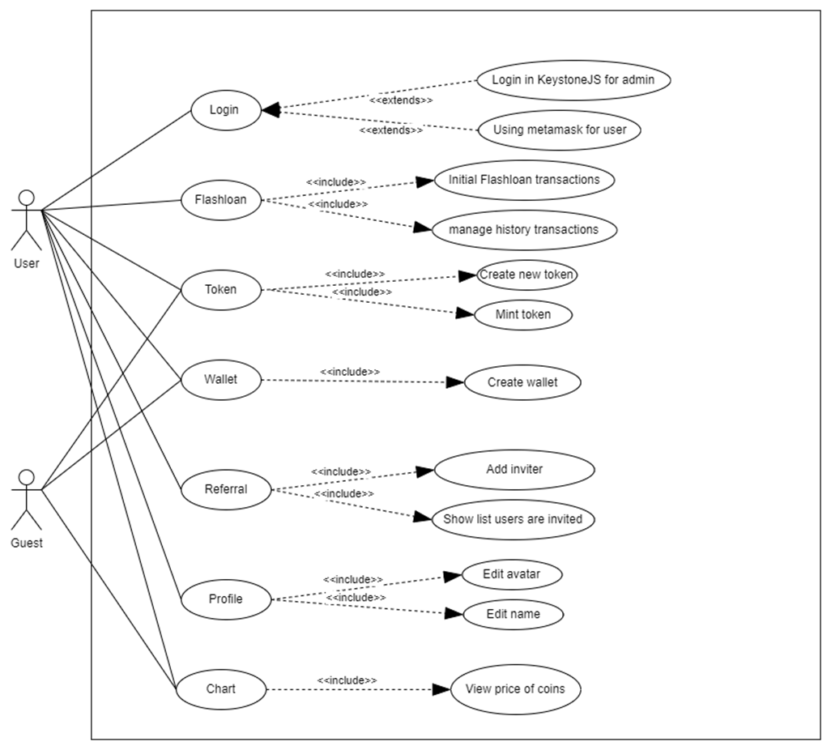

Figure 2‑1

#### View Cryptocurrency Market Information

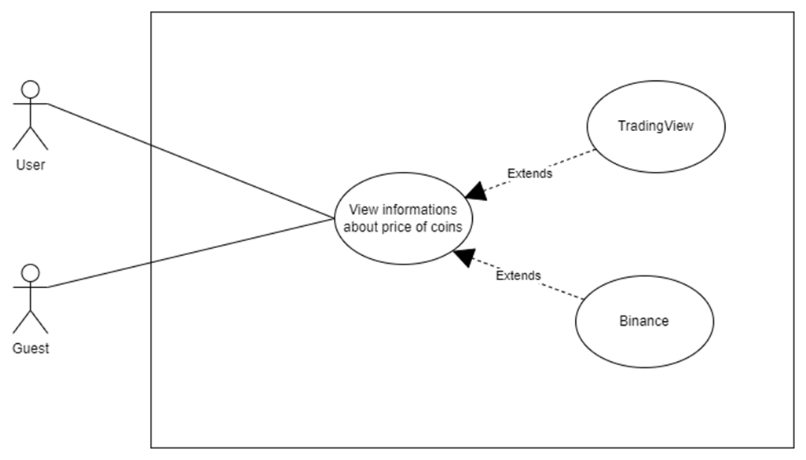

Figure 2‑2

In this function, the application will rely on data provided by famous and trusted exchanges of the cryptocurrency world, TradingView, and Binance, to update the information on cryptocurrencies.

#### Create an e-wallet that stores Ethereum

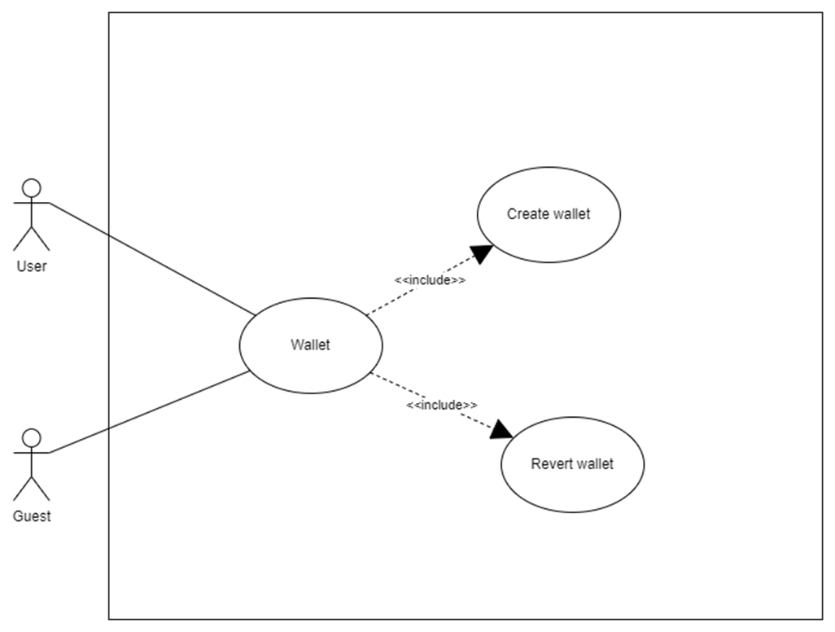

Figure 2‑3

In this section, the application supports creating e-wallet accounts right on the application and after successful creation you will receive the following 3 basic information:

* Public key: your wallet address
* 12 mnemonic phrases to restore your e-wallet
* Private key: The key that allows access to the full functionality of the e-wallet without the need for transaction validation requests.

#### Create, add total supply for your private token

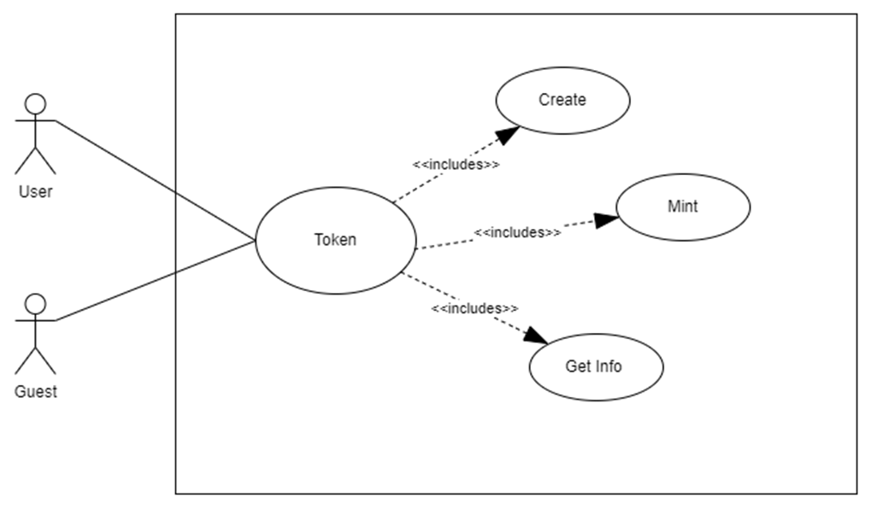

Figure 2‑4

In this section users can create their own simple token and add total supply to that token. All the information that will be displayed is quite necessary about an ERC-20 standard token. The app only allows the token creator to add the total supply for that token.

#### Borrow fast with parameter customization and save transaction history

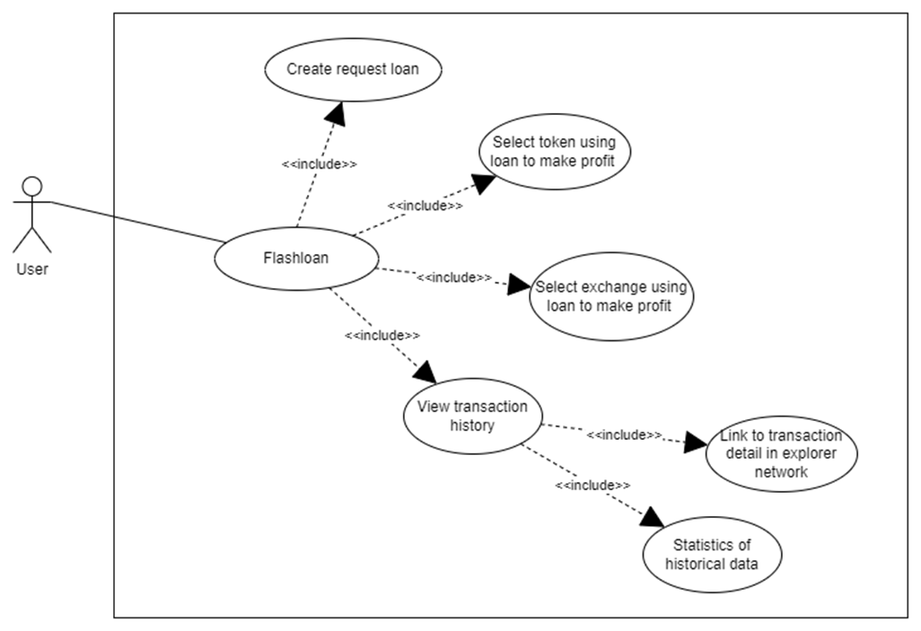

Figure 2‑5

In this section, users will experience the ability to quickly borrow a coin or token and use it to make a quick profit in just a single transaction.

Transaction history is fully saved, detailed statistics and calculation of average profit, highest and lowest profit in the entire loan process on the application.

### Sequence Diagram

Below this to be Sister thing week on one's own belong to the position power main:

#### View Cryptocurrency Market Information

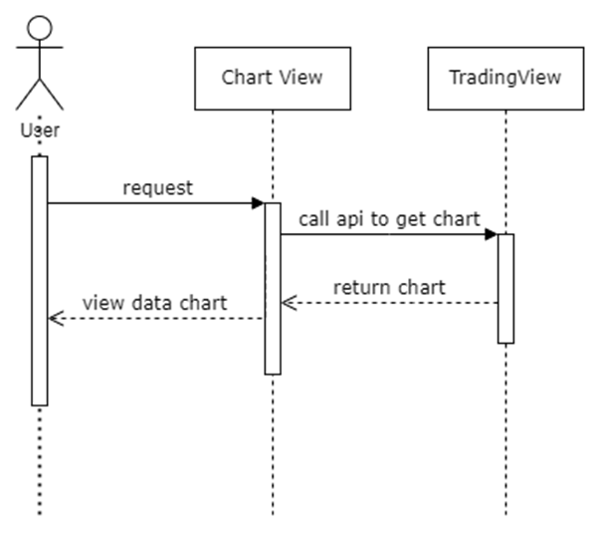

Figure 2‑6

#### Create an e-wallet that stores Ethereum

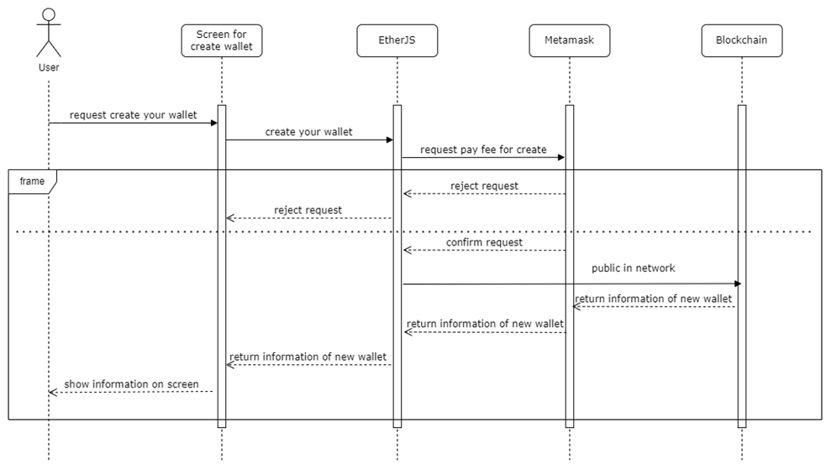

Figure 2‑7

#### Create, add total supply for your private token

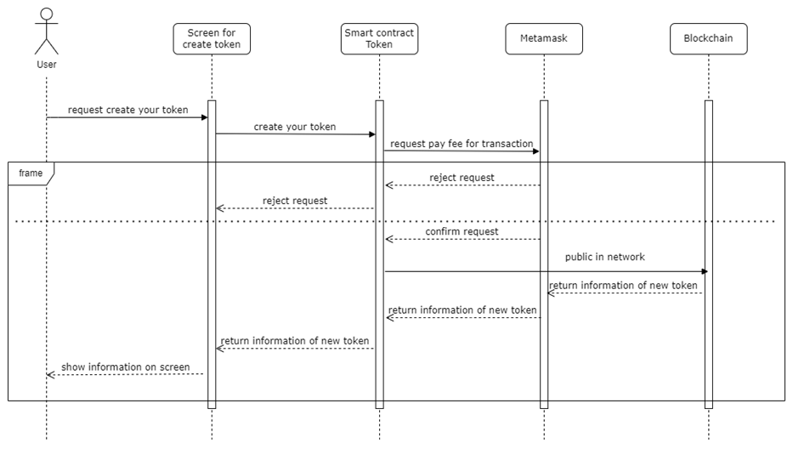

Figure 2‑8

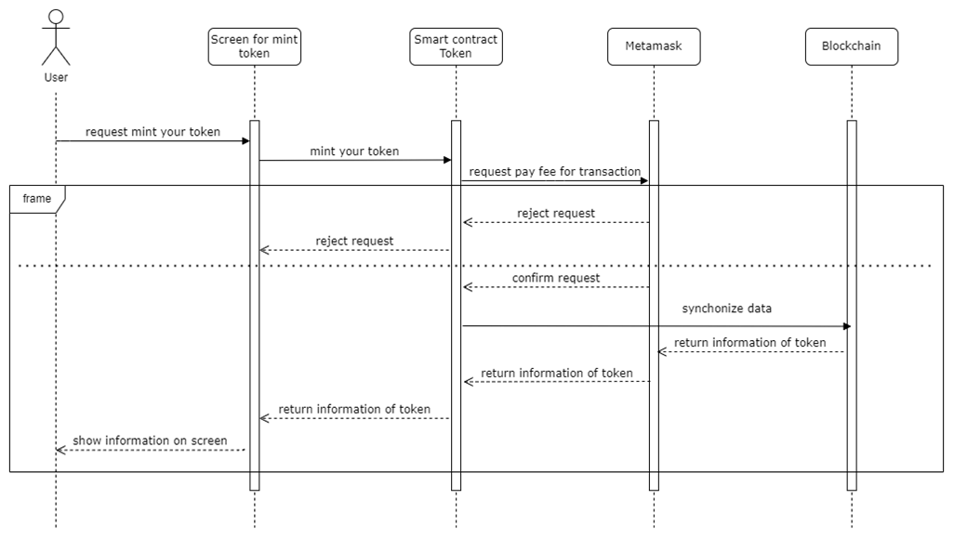

Figure 2‑9

#### Quick loan with custom parameters and save transaction history

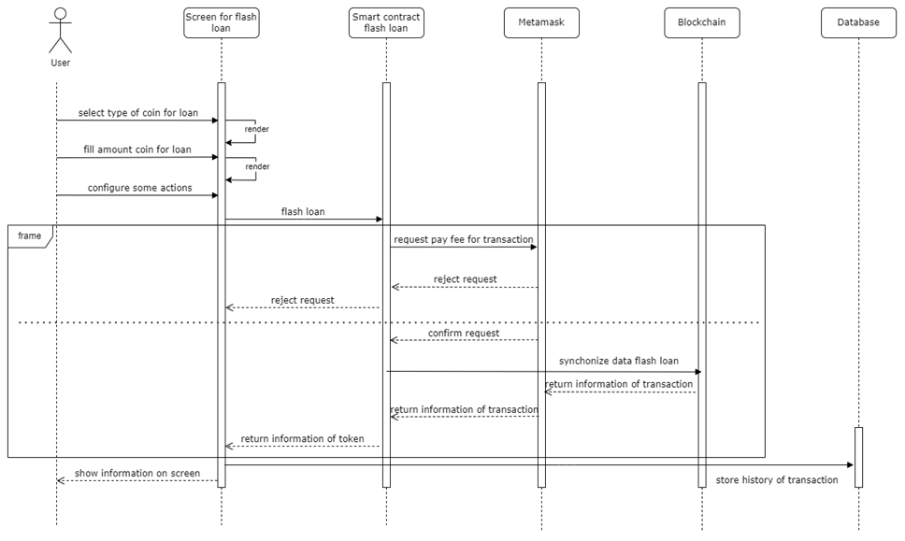

Figure 2‑10

### Class diagram

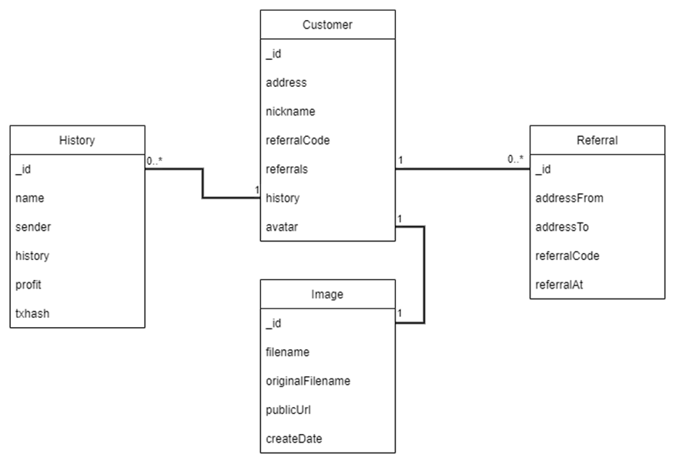

Figure 2‑11

### Database

Since the application is deployed on the blockchain, all data is stored on decentralized data blocks, and the application uses a database to store and manage transaction history information. In addition, it also stores some additional information necessary for the user experience such as images, basic personal information.

The database includes:

* Table Customer

Table 2‑1

|  |  |  |  |
| --- | --- | --- | --- |
| **No.** | **Name** | **Type** | **Allow Null** |
| first | _id | int | FALSE |
| 2 | address | varchar | FALSE |
| 3 | Nick name | varchar | TRUE |
| 4 | referralCode | varchar | FALSE |
| 5 | referrals | int | TRUE |
| 6 | history | int | TRUE |
| 7 | Avatar | varchar | TRUE |

* *History Table*

Table 2‑2

|  |  |  |  |
| --- | --- | --- | --- |
| **No.** | **Name** | **Type** | **Allow Null** |
| first | _id | int | FALSE |
| 2 | name | varchar | FALSE |
| 3 | sender | varchar | FALSE |
| 4 | history | varchar | FALSE |
| 5 | profit | varchar | FALSE |
| 6 | txhash | varchar | FALSE |

* Referral table

Table 2‑3

|  |  |  |  |
| --- | --- | --- | --- |
| **No.** | **Name** | **Type** | **Allow Null** |
| first | _id | int | FALSE |
| 2 | addressFrom | varchar | FALSE |
| 3 | addressTo | varchar | FALSE |
| 4 | referralCode | varchar | FALSE |
| 5 | referralAt | datetime | FALSE |

* Table Image

Table 2‑4

|  |  |  |  |
| --- | --- | --- | --- |
| **No.** | **Name** | **Type** | **Allow Null** |
| first | _id | int | FALSE |
| 2 | filename | varchar | FALSE |
| 3 | originalFilename | varchar | FALSE |
| 4 | publicUrl | varchar | FALSE |
| 5 | createDate | datetime | FALSE |

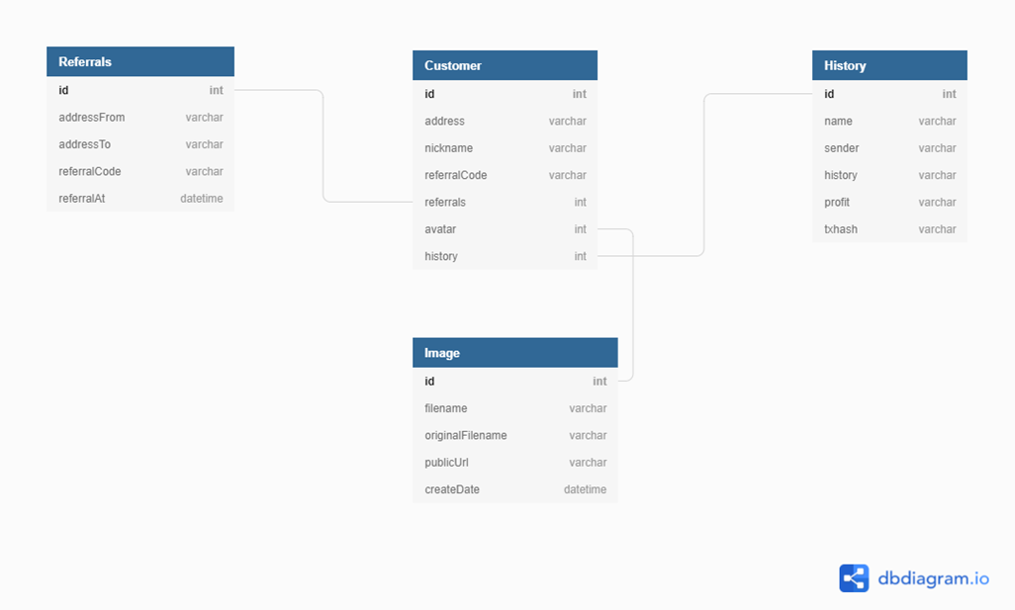

Figure 2‑12

## Virtual assistant (Trợ lý ảo)

### Identify the actors (Actors):

-         **Users:** users use virtual assistants with functions such as asking questions, listening to music, definitions, changing background images, …

### Define use cases:

#### User

-         Show the time

-         Mailing function (under construction)

-         Function to view weather forecast

-         Music playback function on youtube

-         Definition function on Wikipedia dictionary

-         Show assistant functions

### Specification of use cases:

#### Time display use case

●       Actor*:* User

●   Pre-condition: User requires the system to display the time

●   The following conditions: The user uses a virtual assistant.

●   Description: User requested to display the current time.

●       Main events:

Table 2‑5

|  |  |
| --- | --- |
| Actor's actions | System action |
| first.Request time display | 2. Time display and reading |

●        The time display use case is represented by the following graph:

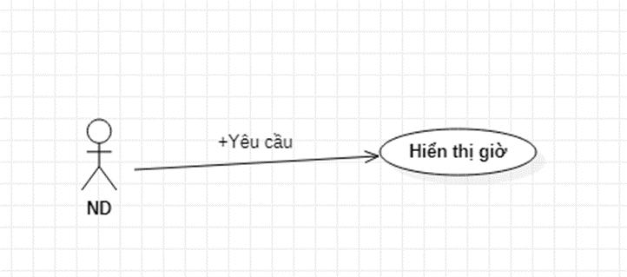

Figure 2‑13

#### Check the weather

·        Actors: User

·        Pre-condition: User is using the system

·        Following conditions: Request to see location information and weather

·        Description: The user wants to see the weather of the specified location.

●    Main events:

Table 2‑6

|  |  |
| --- | --- |
| Actor's actions | System action |
| User requested to see the weather  User reads location | Location inquiry system    Location name check system  System display and read time, |

● *Side events:*

Table 2‑7

|  |  |
| --- | --- |
| Actor's actions | System action |
| Ask the user to review time information | The system will wait to hear about the location  Location confirmation system  The system displays and reads time information |

* The weather view use case is represented by the following diagram:

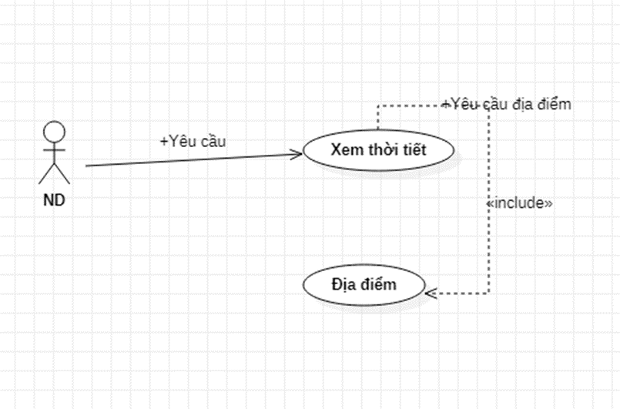

Figure 2‑14

#### Listen to music on youtube

·        Actors: User.

·        Pre-condition: User uses assistant

·        The following condition: User wants to listen to a song

·        Description: The user requests the system to search for information about the song he wants to listen to

·        Main events:

Table 2‑8

|  |  |
| --- | --- |
| Actor's actions | System action |
| 1.User requires music playback system | 2.The system will turn on the browser to search and play the song  3. The system displays search results. |

·        Side events:

Table 2‑9

|  |  |
| --- | --- |
| Actor's actions | System action |
| 3. User did not specify the song | 4 . The system does not display the results. |

  The Music Search use case is represented by the following diagram:

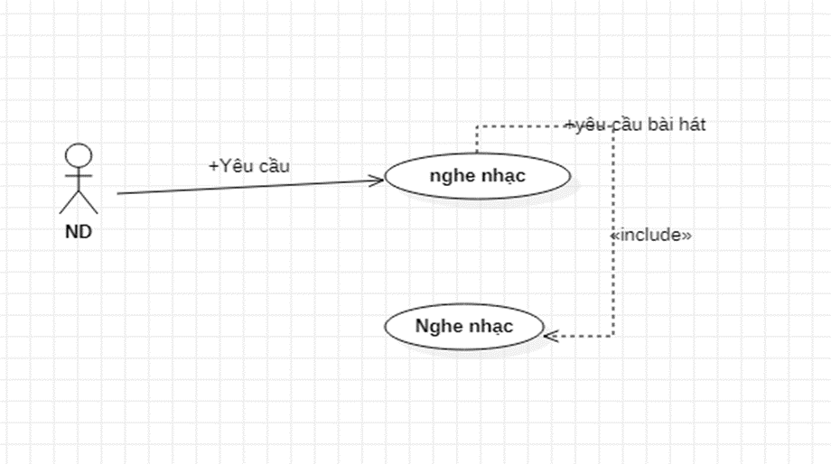

Figure 2‑15

#### Search function

·        Actors: User

·        Pre-condition: User is using the system

·        The following conditions: User requests about the search

·        Description: People who want to find information on the internet

·        Main events

Table 2‑10

|  |  |
| --- | --- |
| Actor's actions | System action |
| 1.Users want to search for information on the network | 2.The system displays the information search form using the browser |

* Use case see product information in the following chart

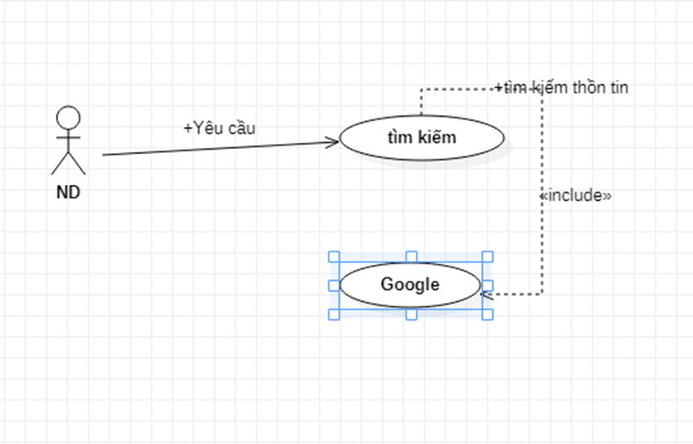

Figure 2‑16

#### See definition from Wikipedia

·        Actors: User.

·        Pre-condition: User is using assistant

·        The following condition: The user has requested to see the definition information about the character or the place

·        Description: User asks for a definition of a place or person

·        Main events

Table 2‑11

|  |  |
| --- | --- |
| Actor's actions | System action |
| 1.User wants to hear the definition | 2. The search system displays information and reads the definition of a place or celebrity |

* Use Case Definition is represented by the following diagram:

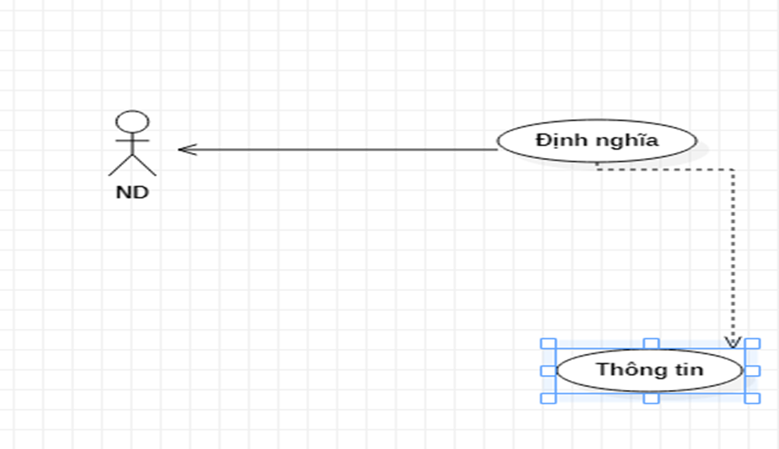

Figure 2‑17

#### Read the paper

·        Actors: User.

·        Pre-condition: User is using virtual assistant

·        The following conditions: Member users have a need to read newspapers to view information and news

·        Description: The user requires the system to open the newspaper to view information and news

·        Main events

Table 2‑12

|  |  |
| --- | --- |
| Actor's actions | System action |
| 1. The user requires the system to open the browser and read the newspaper | 2. The system opens the browser to the newspaper page |

* Use case Reading newspaper is represented by the following diagram:

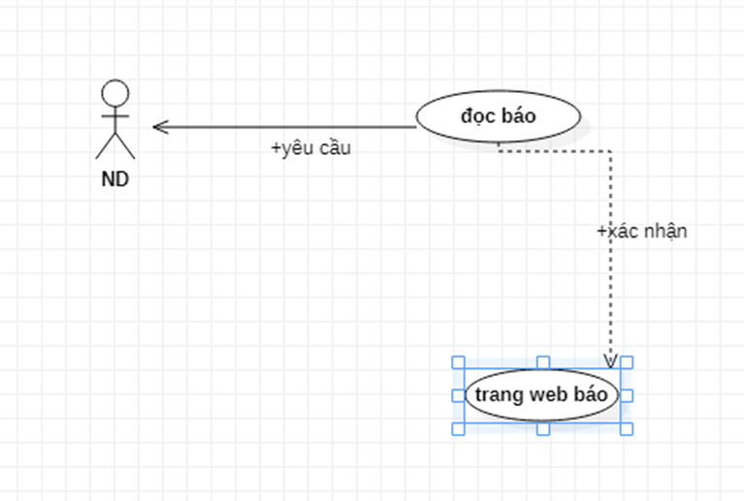

Figure 2‑18

#### Open the app

·        Actors: User.

·        Pre-condition: User is using virtual assistant

·        The following conditions: The user needs to open the application

·        Description: User can open required applications.

·        Main events

Table 2‑13

|  |  |
| --- | --- |
| Actor's actions | System action |
| 1. User request to open the application | 2. Application opening system |

* The Application Open use case is represented by the following diagram:

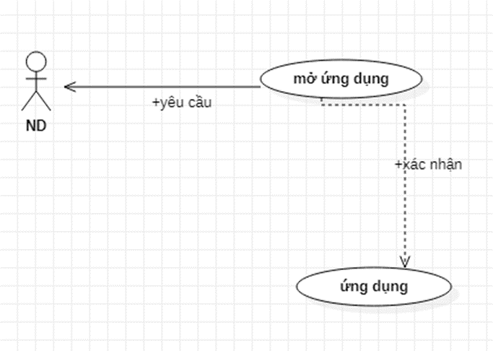

Figure 2‑19

#### Text-to-voice divination

·        Actors: Machine

·        Pre-condition: Machine receives request and voice from user

·        The following condition: Alex is listening

·        Description: Alex hears and converts text to speech so that the user can hear and read it

·        Main events:

Table 2‑14

|  |  |
| --- | --- |
| Actor's actions | System action |
| 1. User read request for Alex | 2.Alex takes orders  4.System 3. Alex searches for information and converts it into text  6.Generation 4. Alex converts text to speech and reads it to the listener |

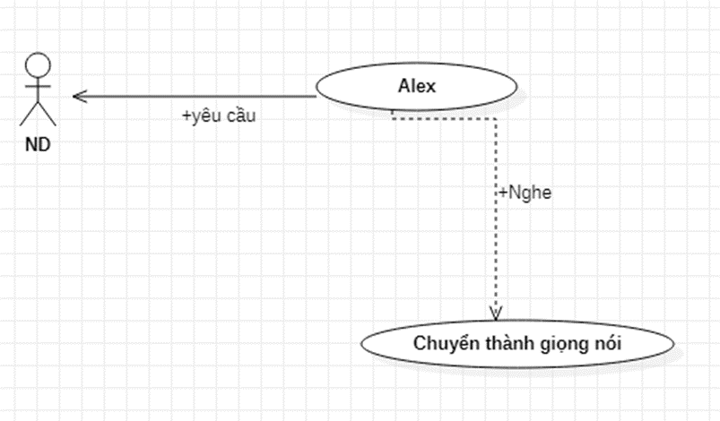

Figure 2‑20

#### Voice to Text

·        Actors: Machine

·        Pre-condition: Machine receives request and voice from user

·        The following condition: Alex is listening

·        Description: Alex hears and converts text to speech so that the user can hear and read it

·        Main events:

Table 2‑15

|  |  |
| --- | --- |
| Actor's actions | System action |
| 1. User read request for Alex | 2.Alex takes orders  4.System 3.. Alex converts request to text  6. |

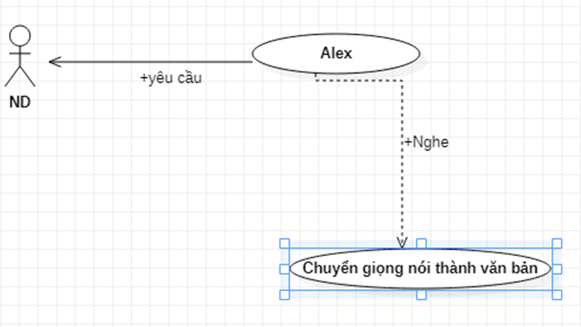

Figure 2‑21

# PROMOTION DECLARATION AND DISCLOSURE RUN TO TRY ON EXPERIENCE

## Lip school develop declare

Smart contract

In this part, I used solidity to write contracts. For convenience more for using and testing the program, can you take advantage of Remix to test? online code. Contracts will be deployed directly on the exchange of Ethereum (tools can than there to be network Kovan ).

Web Apps

Em already history use ReactJS to write Candlestick application this.

Development tools

During the implementation, I used the following tools: Visual Studio Code, KeystoneJS , Mongo DB, metamask, GridFS and Git.

## System Deployment

### **Implementation** **stages**

Stage 1: Select a test deployment network:

Choose Kovan because:

Table 3‑1 *The speed of the Kovan network is quite fast compared to other networks of Ethereum*

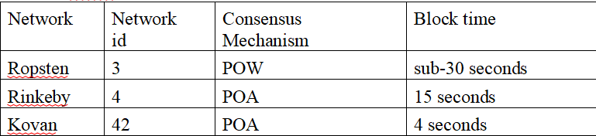

*Stage 2: Choosing a loan protocol:*

*There are loan platforms like AAVE, Compound, Dydx, Uniswap, etc. But AAVE is the first flash loan platform with the advantage of 0.09% loan cost each time (at testnet 0.35%), and Uniswap 0.3%*

*Phase 3: Deploy flash loan smart contract and token exchange transactions to create price difference.*

*Specifically, the exchange of cryptocurrencies (swap tokens) with decentralized exchanges.*

*To complete this stage, the knowledge to learn is how to exchange (swap) coins on decentralized exchanges, specifically in this project uniswap V1, uniswap V2 and sushiswap V2. Includes the following knowledge levels:*

*Implement flash loan mechanism from AAVE protocol here:* [*www.github.com/aave/aave- protocol/blob/master/contracts/lendingpool/LendingPool.sol*](http://www.github.com/aave/aave-protocol/blob/master/contracts/lendingpool/LendingPool.sol) *.*

*Notably the flashloan and executeOperation*

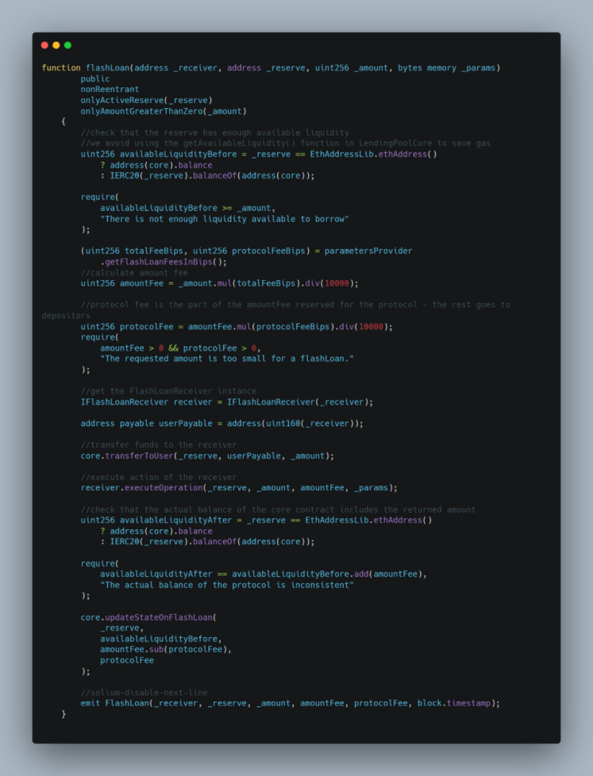

Figure 3‑1

+ Swap with Uniswap V1 using createExchange( ) function, tokenToTokenSwapInput():

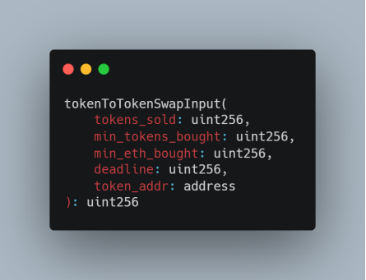

Figure 3‑2

Table 3‑2

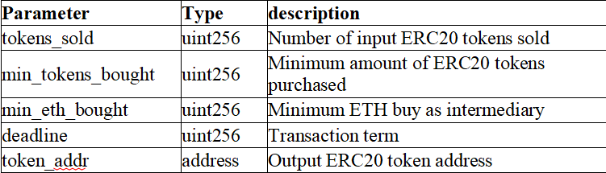

Swap by Uniswap V2 delegate to a contract address and call the UniswapV2Router02 interface using the swapExactTokenForTokens( ) functions.

Table 3‑3

|  |  |  |
| --- | --- | --- |
| **Name** | **Type** |  |
| amountIn | uint | Number of input tokens to send |
| amountOutMin | uint | Minimum amount of output tokens that must be received for the transaction to not revert |
| Path | address[ ] calldata | An array of token addresses path.length >= 2, Pools for each consecutive pair of addresses must be live and liquid |
| Big | address | Output token receiver |
| deadline | uint | The time after which the transaction will revert |
|  |  |  |
| amounts | uint[ ] memory | Amount of input tokens and all subsequent output tokens |

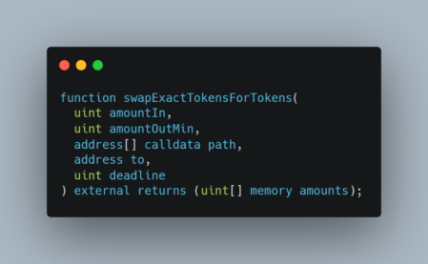

Figure 3‑3

Phase 4: Set up a test environment for the application by creating tokens, setting prices on exchanges according to token pairs or anchoring a part of the price of Ethereum.

In order to set up a functional testing environment and application experience, the following requirements are needed:

+ Visit faucets.chain .link page to get as much ETH as possible and use it to deploy the project.

+ Generate tokens and add total supply stored in wallet holder

+ Add tokens to exchanges and create price differences for favorable flash loans.

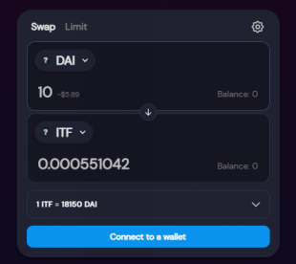

Figure 3‑4

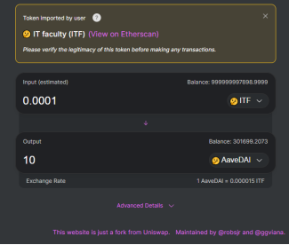

Figure 3‑5

Stage 5: Build a friendly interactive interface and deploy into a product.

### Algorithm analysis

A special feature of flash loans is that the entire process of borrowing and buying and selling until repayment, all happens in a single transaction. This kite makes a big difference.

**The essence of a flash loan is a loan that must be repaid immediately after the transaction closes.** Specifically:

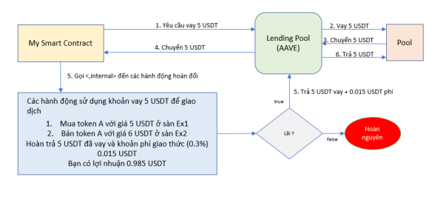

Figure 3‑6

Step 1: My Smart Contract requires borrowing an amount of 5 USDT tokens to the protocol

Step 2: Loan liquidity pool request protocol

Step 3: Liquidity pool transfers 5 USDT to the processing protocol

Step 4: Protocol to transfer 5 USDT to My Smart Contract for processing

Here 5 USDT is used to manipulate 2 actions:

1 is Buy token A on Ex1 exchange for 5 USDT

2 is Selling token A on Ex2 exchange for 6 USDT

After checking profit, do step 5, otherwise stop the program and revert the trade.

Step 5: Refund borrowed 5 USDT + 0.015 USDT loan protocol initialization fee

Step 6: Loan repayment protocol to the liquidity pool

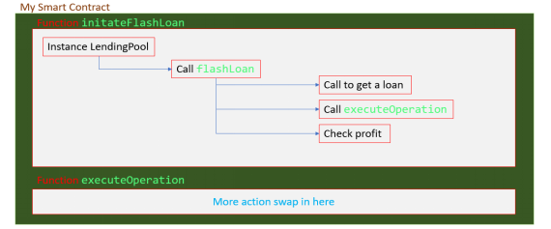

Figure 3‑7

In the image above, My Smart Contract instantiates an instance of LendingPool and calls its flashloan function. Inside this function, contains a function call to a function that executes the ACTION flash loan in My Smart Contract which defines itself as executeOperation. Until the end of the function call, when the ACTION operations have been completed, can LendingPool check the transaction results to be profitable or not? And that ensures the integrity of the loan.

**The purpose of using flash loans is to generate income by arbitrage. So why is the price difference?**

The price of any coin on centralized or decentralized exchanges at a time has different fluctuations. Detail:

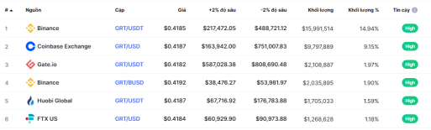

Figure 3‑8

Particularly for decentralized exchanges, the price of a coin depends on the ORACLE protocol that the exchange uses to get price data. ORACLE here is the protocol that helps convert off-chain data into on-chain data.

As you know about the blockchain network, if you want to authenticate data, you must authenticate with many nodes in the network. That slows down the process of updating price data between exchanges leading to information lag causing price discrepancies.

Using a different ORACLE protocol also results in discrepancies because of the different algorithms.

In addition, the current problem is still a huge obstacle, that is, the network infrastructure is low, the data transmission speed cannot be instantaneous, but it always has a certain delay.

above problems lead to the price at a time on the exchanges will be different.

**The question is, how does Flash loan spread the price difference?**

That is buying on the low price floor and selling on the high price floor. The feature of the flash loan protocol is that the transaction is fast and the entire transaction takes place in a single transaction. Ensure lightning, instant loan and conversion transactions on exchanges.

## Demo results and program instructions

### View Cryptocurrency Market Information

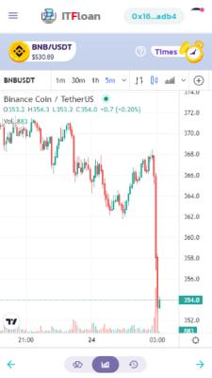

Figure 3‑9

On this screen, the chart section displays the chart of the cryptocurrency the user is interested in. You can also find and view the prices of other cryptocurrencies by different timeframes and custom chart types.

To the minute-by-minute timeframe chart, the data will be updated in real time with the price of each type.

### Create an e-wallet that stores Ethereum

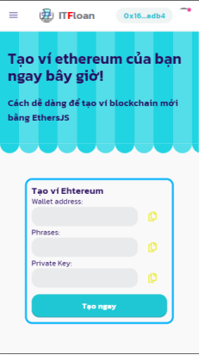

Figure 3‑10

As long as there is a need to create a wallet, the application will immediately create an electronic wallet with 3 basic parameters:

· Wallet address (public key)

· Phrase to restore 12-digit wallet

· The secret key is intended to allow direct interaction with transactions without requiring payment validation prior to each transaction

### Create, add total supply for your private token

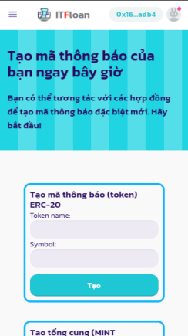

Figure 3‑11

In this section, the user can create a token with the name and symbol parameter that immediately created a token with the owner being the wallet that just initiated the creation operation.

In order to use that token, it is necessary to add a mint step (to create a total supply) for the token to circulate.

Then allow it to circulate on the exchange and validate it as an ERC-20 token.

### Fast loan with parameter customization

B1: Select the coin you want to borrow

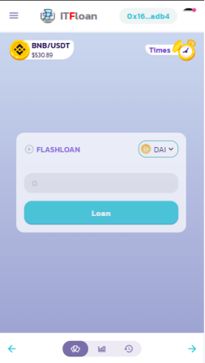

Figure 3‑12

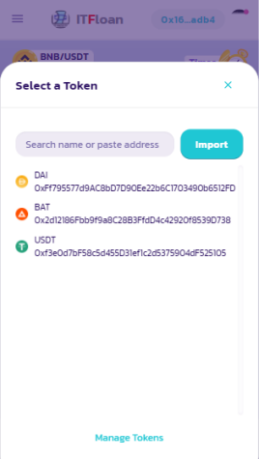

Figure 3‑13

B2: Enter the amount of coins you want to borrow and click the Add button to add activities after successful borrowing

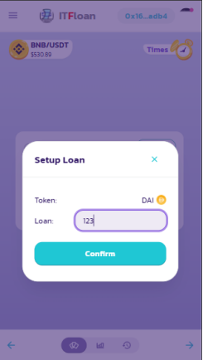

Figure 3‑14

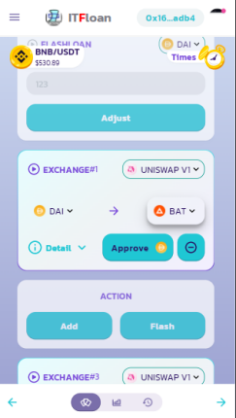

Figure 3‑15

B3: Select the exchanges, the coins you want to exchange (swap) between those exchanges so that they can generate the best possible profit based on the user's strategy.

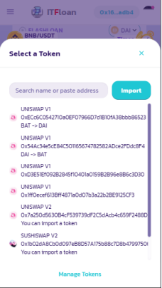

Figure 3‑16

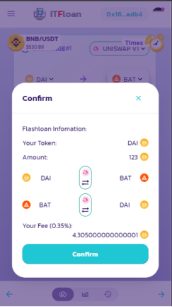

Figure 3‑17

B4: Verify the transaction and wait for the result

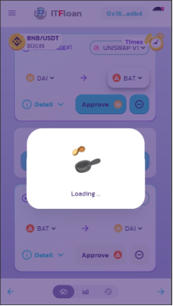

Figure 3‑18

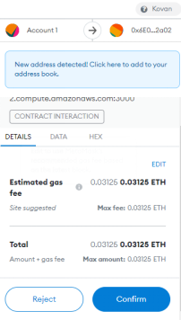

Figure 3‑19

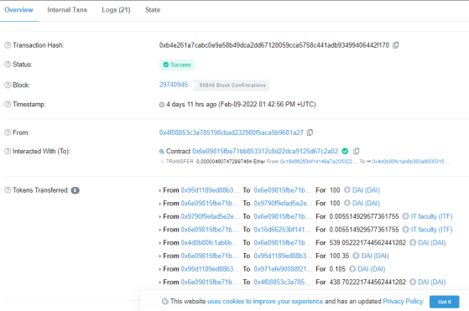

Figure 3‑20

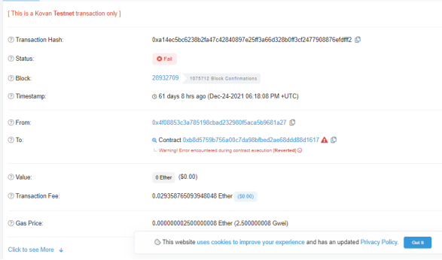

Figure 3‑21

### Save quick loan history and statistics

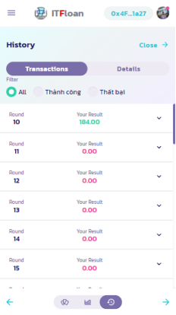

Figure 3‑22

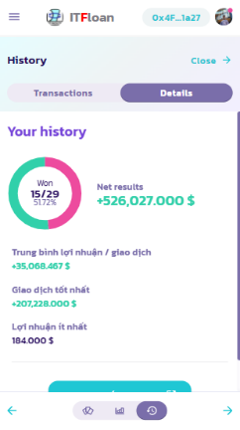

Figure 3‑23

The transaction history will be saved on a centralized database, specifically in this application, the mongoDB cloud, and manage that data with the KeystoneJS library that uses graphQL for queries and related interactions.

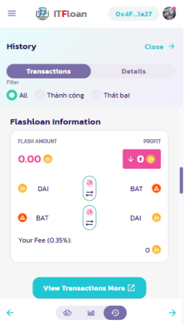

Figure 3‑24



Figure 3‑25

Besides managing this information, it is easy to access transaction history stored on a centralized database.

In this case, the system is not capable of saving history on a decentralized database because in case if the flash loan transaction fails all its data is not saved on the blockchain.

### Manage login to retrieve transaction history information

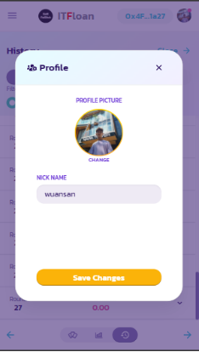

Figure 3‑26

With the goal of creating interaction in terms of images, nicknames instead of using wallet addresses.

### Invite friends to experience the app

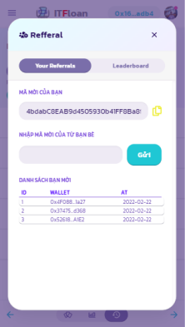

Figure 3‑27

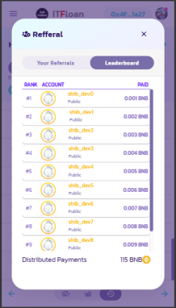

Figure 3‑28

The application has the function of inviting friends to use and experience this flash loan application and the larger the number of invites, the more likely it is to receive a certain amount of tokens or a valuable reward.

With the purpose of attracting as many users as possible to experience and evaluate the features and performance of the system.

### Evaluate

- Advantages

* Basically, the application was able to make a simple and fast crypto loan.
* Create an environment where cryptocurrency traders can keep track of any price information at any time they want. In addition, there is a page that is constantly updated with basic information and questions about the flash loan application
* Transparency of loans because it only takes place in a single transaction, the ability to use that money to transfer to an e-wallet is not possible.
* Leverage the limitation of blockchain infrastructure to eat arbitrage between cryptocurrency exchanges
* Transactions are processed faster and more economically than individually operated coin swaps.

- Defect

* To make a profit, you must have a strategy and study very carefully the price of cryptocurrencies, as well as the extremely fast transmission network speed.
* On the current blockchain, there are still many protocols that are not capable of resisting attacks and manipulations using Flash loans, so there are many potential risks in the market.
* The application is only built for testing and research purposes, the cost of building on the mainnet is quite expensive, so it can only be deployed on the test network.

CONCLUSIONS AND SUGGESTIONS

1. Conclusions

After building this system, it is possible to understand how to build a web application that interacts with the blockchain network. From building the interface, processing the data to deploying the system into a packaged product on a hosting and linking it to a custom domain name.

I also improved my skills a lot, including my research skills rescue, carefully power carefully art, language Brother, theory submit also like rather lots of carefully it soft need yes is different..

Regarding the project, I followed the plan created in the first week of the time to do the graduation project and perform all the functions in that plan . I also try to make the application as flexible and as close to the goal as possible destination elevate High spread test People use.

1. Suggestions

With some of the disadvantages I mentioned in the review, the future work of this project will be as follows:

- Try to perfect it and deploy it on the official Ethereum network

- Expand to more detailed tutorials, more specific explanations of the application and its true capabilities.

- Add interesting services and functions to attract user interaction.

- Further, the application can deploy not only the Ethereum network but also other networks such as Near, Polkadot, Avalanche, etc.

REFERENCES

[ 1 ]<https://www.v5.keystonejs.com/> ,

[ 2 ]<https://www.graphql.org/> ,

[ 3 ] https://www.restapitutorial.com/ ,

[ 4 ] https://www.reactjs.org/ ,

[5 [] https://github.com/ethereum/EIPs/blob/master/EIPS/eip-20.md/](https://github.com/ethereum/EIPs/blob/master/EIPS/eip-20.md)

[6]<https://solidity.readthedocs.io/en/v0.5.13/> ,

[ 7 ] https://iztuts.com/bai-1-gioi-thieu-keystonejs/ ,

[8]<https://piyopiyo.medium.com/how-to-generate-ethereum-wallet-with-ethers-js-d0ef74eadfd8> ,

[ 9 ] https://coin568.com/poa-la-gi/ ,

[ 10 ] https://www.youtube.com/watch?v=vcvPeqhrbzk ,